**Name: Jvalant Patel**

**SJSU ID: 010028408**

**Lab #5 - Design Patterns Lab - Part 3**

**Class Diagram:**

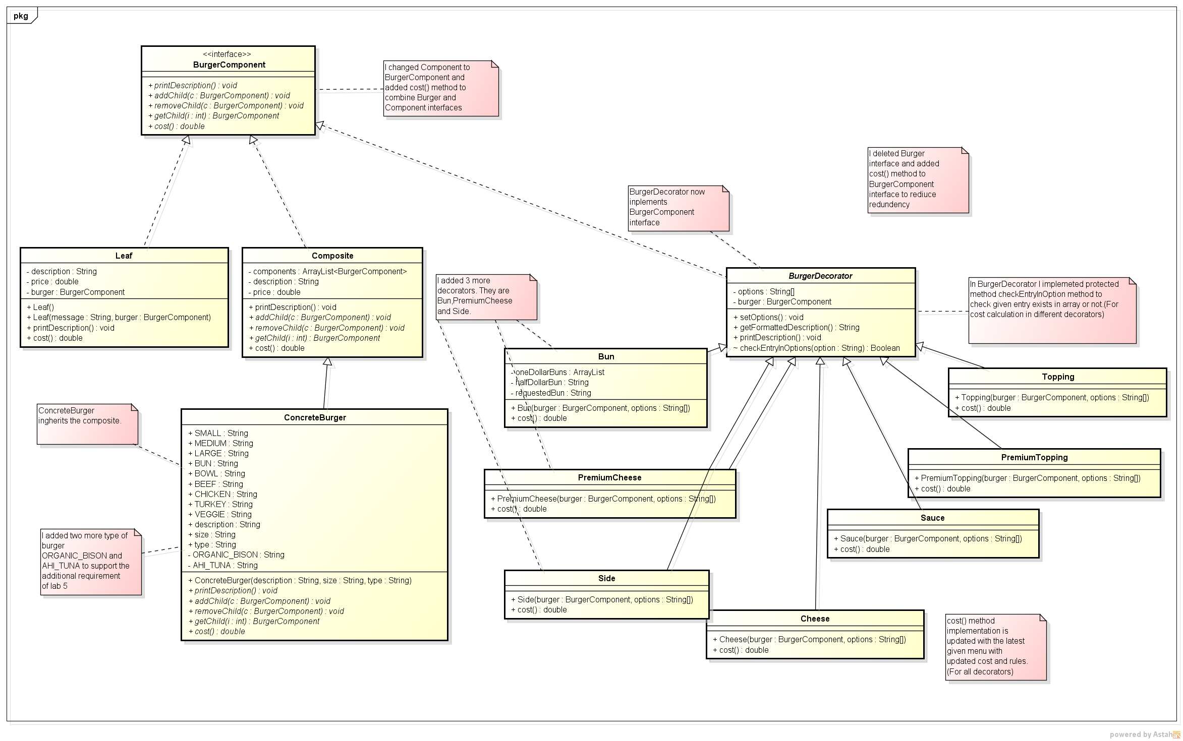

**Output of the solution (Build your own Burger)**

